**Perception System:**

**Overview:**

The purpose of the perception system is to provide for simultaneous localization and mapping as the quad explores an unknown space. In particular, the system needs to provide a local position estimate for the higher-level planning systems to be able to make progress towards a goal.

**Requirements Breakdown:**

|  |  |  |  |
| --- | --- | --- | --- |
| **Level 1** | **Level 2** | **Level 3** |  |
| The system shall perform a search for targets | The system shall visually verify targets | 1.1.1 | The system shall have visual sensor(s) |
|  |  | 1.1.2 | The system shall be capable of processing imagery |
|  | The system shall navigate an unknown environment using partial prior information | 1.2.1 | The system shall avoid unrecoverable collisions with obstacles |
|  |  | 1.2.2 | The system shall plan vehicle trajectories through the environment |

|  |  |  |  |
| --- | --- | --- | --- |
| **Level 1** | **Level 2** | **Level 3** |  |
| The system shall track visually identified targets | Each PPU shall have the ability to track targets | 2.1.1 | The PPU shall estimate target position to within 0.5 m |
| The system shall be autonomous | The system shall not rely on external processing | 4.1.2 | The system shall perform perception onboard |

**Requirements Implementation:**

|  |  |  |
| --- | --- | --- |
| **Level 3** | **How is Requirement Satisfied** |  |
| 1.1.1 | The system shall have visual sensor(s) | Guidance cameras |
| 1.1.2 | The system shall be capable of processing imagery | Guidance and software pipelines |
| 1.2.1 | The system shall avoid unrecoverable collisions with obstacles | Obstacle detection via Guidance |
| 1.2.2 | The system shall plan vehicle trajectories through the environment | Map production from RTABMap |

|  |  |  |
| --- | --- | --- |
| **Level 3** | **How is Requirement Satisfied** |  |
| 2.1.1 | The PPU shall estimate target position to within 0.5 m | Software stereo pipeline's depth image coupled with RTABMap position estimate |
| 4.1.2 | The system shall perform perception onboard | Guidance + RTABMap |

**Method:**

SLAM solutions require some sort of ranging sensor; we chose a purely visual system based on stereo vision instead of a laser rangefinder-based solution. Among potential SLAM implementations available, we chose RTABMap for its flexibility and appropriateness to the space at had. Other solutions could not take advantage of loop closures, or required additional sensing to resolve scale issues. RTABMap has neither of those limitations.

As a camera source, we chose Guidance(Figure Figure), a system by DJI, in the hopes that its processing front-end would reduce the CPU utilization needed by a SLAM solution. The primary challenge has been integrating Guidance into a SLAM algorithm. Ideally, Guidance's visual odometry estimate is 'good enough' to be a strong prior on the SLAM estimate. RTABMap is set up to accept stereo inputs as raw data sources – we can export the grayscale rectified imagery from Guidance for use in mapping. Essentially, we use Guidance as a glorified stereo camera pair. Preliminary testing has been completed that uses Guidance as a simple image provider, without utilizing its visual odometry output. In this preliminary test, a stereo odometer is used in software to estimate motion in the SLAM algorithm. This software will be changed out to use Guidance's output once coordinate frames and other integration issues are sorted out.

Figure 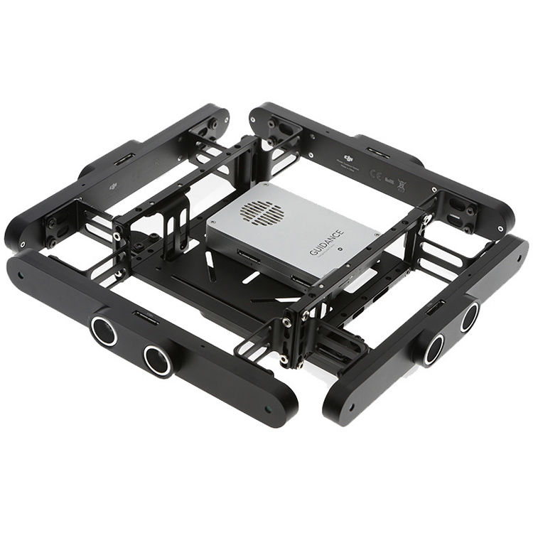1: The Guidance Sensor on its mounting bracket

**Block Diagrams:**

Figure 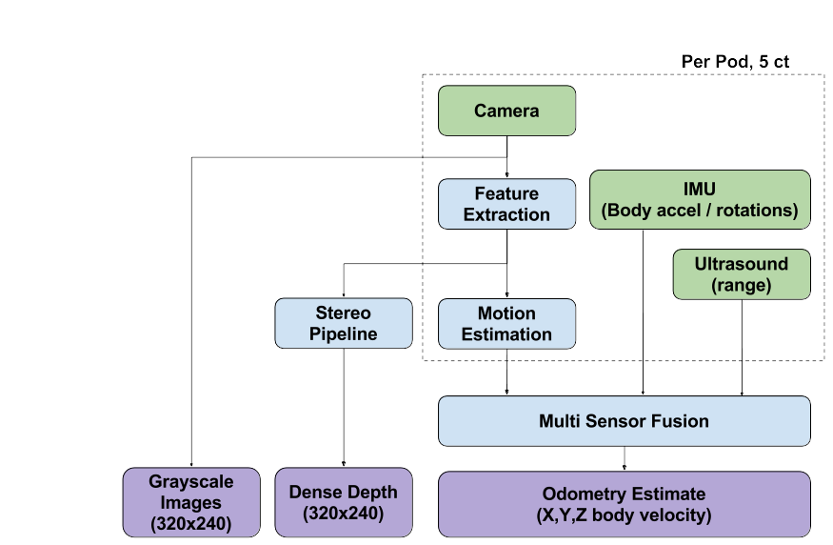2: Guidance Sensor. Purple are data products, green are sensors, and light blue are processing steps

Figure 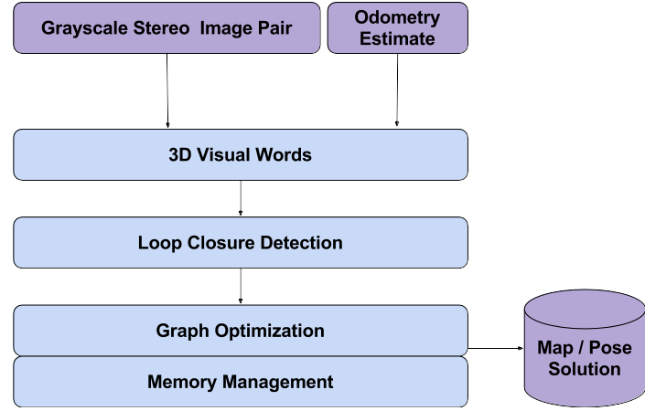3: RTABMap Block Diagram. Purple are data products, light blue are processing steps.

Figure 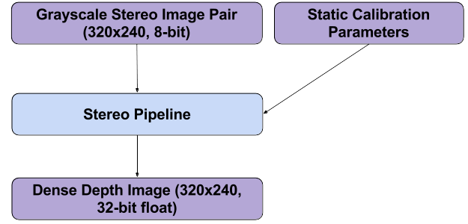4: Stereo pipeline. Purple are data products, light blue are processing steps.

**Problems:**

The RTABMap implementation is very much a black box, with many knobs to tweak. Any assertion that SLAM is a solved problem is somewhat short-sighted. Initial testing has confirmed that the carpet may pose a problem for feature-based tracking due to a lack of features. One lab has used newspapers taped together as a floor for their visual quad operations – this type of texturing may prove appropriate for us as well. Examples of generated maps are included in Figures Figure and Figure.

Guidance has shown certain instabilities in operation that are troubling for use in a real system. For example, the USB interface sometimes does not reset, requiring Guidance to be power cycled to recover operations. The team observed one test that had the visual odometry output of Guidance stop while the sensor was moving, only to recover once motion had stopped. Additionally, visual odometry seems to be only calculated from the bottom-facing camera pair, requiring a highly textured floor for meaningful results to be obtained. In general, Guidance seems to not be sufficiently developed to recommend its use in further development; a conventional RGBD camera such as an Asus Xtion Pro Live might be a better choice going forward.

Figure 5: Map resulting from Guidance's depth map

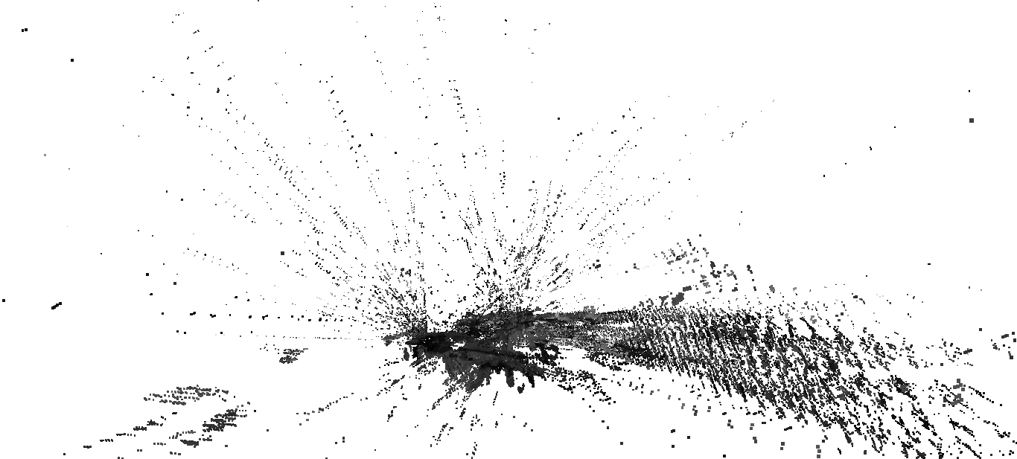

Figure 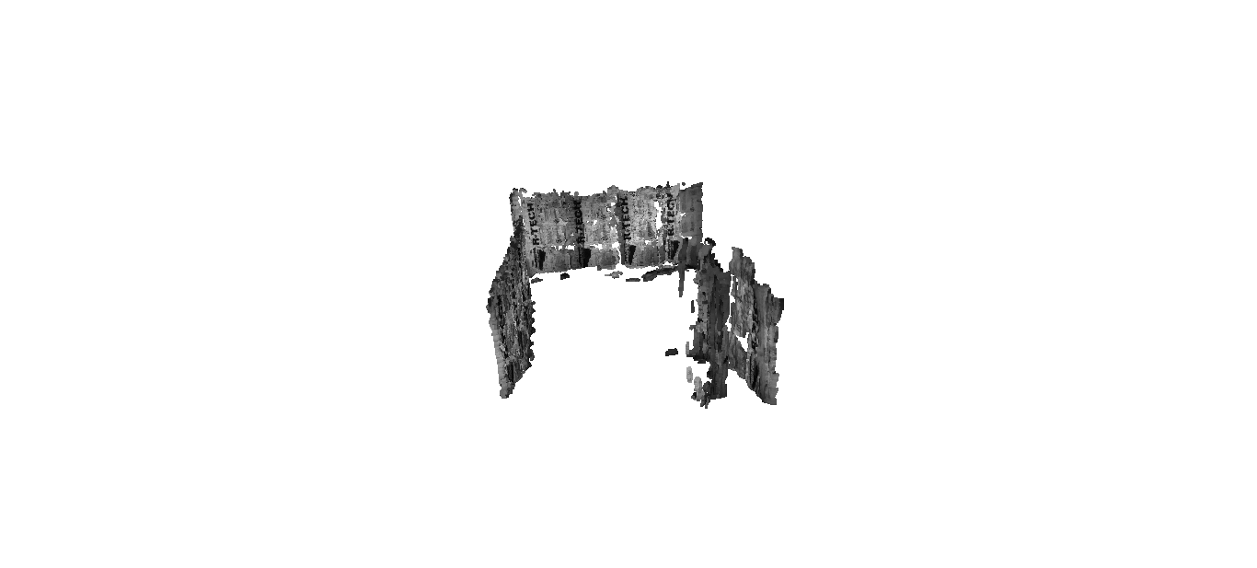6: Map resulting from RTABMap's stereo pipeline

